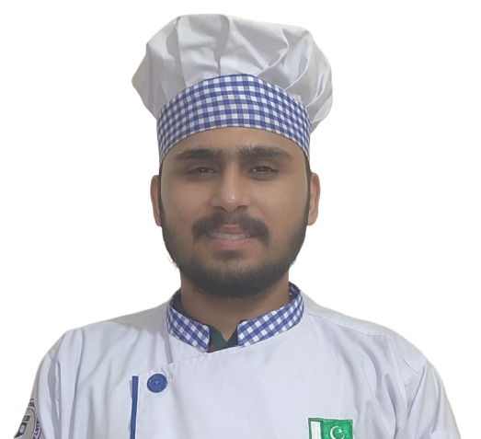 |  | Muhammad Abu Bakar  Professional Chef
Profile  Passionate and detail-oriented chef with extensive experience in culinary arts, menu development, and kitchen leadership.  Skilled in creating diverse, innovative menus while ensuring top-quality standards, food safety, and cost efficiency. Adept at leading kitchen teams to deliver exceptional dining experiences  Contact  PHONE:  +923164271005  EMAIL:  abubakartanveer3145@gmail.com  Hobbies  Food photography  Traveling  Fitness  Cricket  Certifications  Mise en place  Delivering Passionate Services  Body Language Basics  Effective Communication with Staff  Customer (Experiential) Services  References  Available upon request. |  | EDUCATION  College of Tourism and Hotel management  Jan 2025 – Oct 2025  Diploma in Culinary Arts  - Specialized in Chinese and Pakistani cuisine  - Hands-on training in menu development and cost control  - Received food safety certification Level-2  Islamia College Civil Lines  May 2021 – Jul 2023  Intermediate Education  WORK EXPERIENCE  Trainee Chef – Practical Training  Jan 2025–Sep 2025  - Assisted senior chefs in daily kitchen operations, including food preparation and plating.  - Learned and applied fundamental cooking techniques, knife skills, and portion control.  - Ensured compliance with hygiene and food safety standards  - Supported menu planning, inventory checks, and portion control.  - Collaborated with kitchen staff to deliver high-quality dishes under time constraints.  SKILLS  - Knife skills & cooking techniques  - Menu planning & food preparation  - Food safety & hygiene (HACCP)  - Presentation  - Kitchen operations  - Teamwork under pressure

